

**DEPARTMENT OF COMPUTER SCIENCE AND ENGINEERING**

**AI-BASED HAND GESTURE CONTROL SYSTEM**



**PRODUCT DEVELOPMENT**

**Report for** **Product Development**

|  |  |  |
| --- | --- | --- |
|  | Title of the Product | AI-Based Hand Gesture Control System |
|  | Name of the Faculty | 1.Dr.A.Neelamadheswari  2. Ms.S.Sowmiya |
|  | Name of the Student | 1.Kathiravan M  2. Manikandan M  3. Manoj M |
|  | Objective of the Product | The objective of this project is to develop a touchless system that allows users to control their computer using hand gestures detected through a webcam. It aims to perform actions like cut, copy, paste, scroll, screenshot, and app launching using AI-based gesture recognition. The goal is to create an accessible, low-cost, and user-friendly solution for smarter and more hygienic human-computer interaction. |
|  | Outcome of the Product | The product successfully enables users to control their computer using hand gestures without touching the keyboard or mouse. It performs actions like cut, copy, paste, scrolling, taking screenshots, and opening apps with high accuracy using a webcam. The system is low-cost, easy to use, and provides a clean, contactless interface, making it suitable for both personal and professional use. |
|  | Mapping of Program Outcome | PO1, PO2, PO3, PO4, PO5, PO6, PO7, PO8, PO9, PO10, PO11, PO12 |
|  | Mapping of Program Specific Outcome | PSO1, PSO2, PO3, PO5, PO10 |
|  | Tools/Software used: | Python, OpenCV , MediaPipe ,PyAutoGUI ,Visual Studio Code, Webcam |
|  | Research Laboratory Involvement | - |
|  | Application/Industry relevance | Healthcare, Education |
|  | Research paper published/Patent filed / product exhibited (If applicable) | - |

Signature of the Faculty In charge Signature of the HOD

**TABLE OF CONTENTS**

|  |  |  |
| --- | --- | --- |
| **S.No.** | **TITLE** | **PAGE NO** |
|  | Introduction | 06 |
|  | Objective | 07 |
|  | Development Process | 08 |
|  | Innovation | 12 |
|  | Outcome | 13 |
|  | Student Learning Outcomes | 15 |
|  | Future Scope | 16 |
|  | Tools / Software Used | 17 |
|  | Application / Industry Relevance | 19 |
|  | Testing, Final Assembly, and Troubleshooting | 20 |
|  | Conclusion and Recommendations | 22 |

# **MAHENDRA ENGINEERING COLLEGE**

## (Autonomous)

**DEPARTMENT OF COMPUTER SCIENCE AND ENGINEERING**

### **VISION**

* To produce competent computer engineers proficient with state of the art technologies

### **MISSION**

* To impart good quality technical education through effective teaching-learning process
* To enhance the students employability through mentoring and skill development
* To promote innovation and research activities with analytical skills to face global challenges
* To enable students imbibe ethical and enterprising characteristics to become socially responsible engineers

**CO-PO Attainment Table**

|  |  |  |  |  |  |  |  |  |  |  |  |  |
| --- | --- | --- | --- | --- | --- | --- | --- | --- | --- | --- | --- | --- |
| **Course Outcomes (COs)** | **PO1** | **PO2** | **PO3** | **PO4** | **PO5** | **PO6** | **PO7** | **PO8** | **PO9** | **PO10** | **PO11** | **PO12** |
| CO1: Understand and apply AI & CV techniques | ✓ | ✓ | ✓ |  | ✓ |  |  |  |  |  |  | ✓ |
| CO2: Design a real-time hand gesture system | ✓ | ✓ | ✓ | ✓ | ✓ | ✓ |  |  | ✓ | ✓ |  | ✓ |
| CO3: Use modern tools for gesture recognition | ✓ |  | ✓ |  | ✓ |  |  |  |  | ✓ |  | ✓ |
| CO4: Communicate results and manage projects |  |  | ✓ |  |  |  |  |  | ✓ | ✓ | ✓ | ✓ |
| CO5: Demonstrate social and hygienic impact |  |  |  |  | ✓ | ✓ | ✓ | ✓ |  |  |  | ✓ |

**AI-Based Hand Gesture Control System**

#### **1.INTRODUCTION**

Hand gesture recognition is a modern technology that allows users to interact with computers using natural hand movements instead of traditional devices like a keyboard or mouse. This method makes it easier and faster to perform common tasks without physically touching the system, which is especially helpful in situations requiring hygiene or hands-free operation.This project focuses on developing a smart system that recognizes various hand gestures through a regular webcam. Using AI techniques and computer vision libraries such as OpenCV and MediaPipe, the system tracks hand movements in real time. Different finger positions are mapped to specific commands like cut, copy, paste, taking screenshots, scrolling documents, and launching applications.

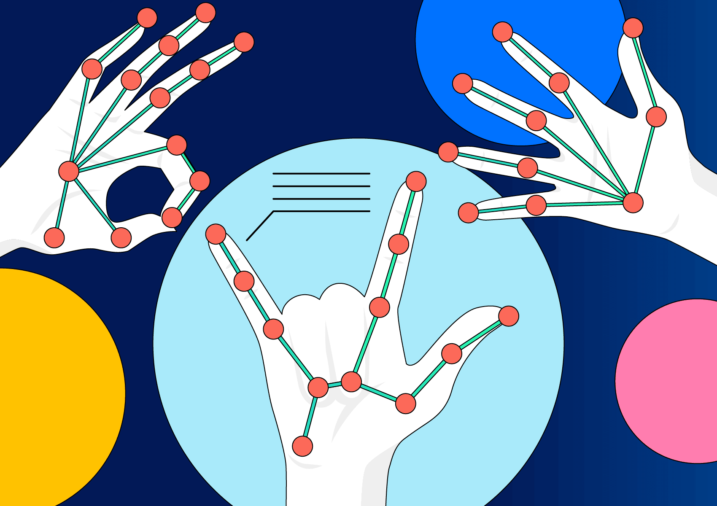

The main goal is to create a user-friendly and cost-effective solution that can improve accessibility and convenience. It can be used in offices, classrooms, healthcare environments, and for people with physical disabilities who find traditional input devices challenging.

By combining AI with everyday computer tasks, this project aims to enhance interaction with technology in a more natural and efficient way.

**2.OBJECTIVE**

The main objective of this project is to develop an AI-based hand gesture control system that enables users to perform common computer functions without using a keyboard or mouse. The system aims to:

* Recognize various hand gestures accurately using a webcam and AI-based computer vision techniques.
* Map specific gestures to functions like cut, copy, paste, take screenshots, scroll documents, and open applications.
* Provide a touchless and user-friendly interface for better accessibility and hygiene.
* Create a low-cost and easy-to-use system that can work on standard computers without additional hardware.
* Improve human-computer interaction by making it faster and more natural.

# **3.DEVELOPMENT PROCESS**

The development of the AI-Based Hand Gesture Control System involved the following key steps:

1. **Requirement Analysis:**  
   Identified the need for a contactless computer control system that can perform tasks like cut, copy, paste, screenshot capture, scrolling, and launching applications using hand gestures.
2. **Technology Selection:**  
   Chose Python as the programming language and used libraries such as OpenCV for image processing, MediaPipe for hand landmark detection, and PyAutoGUI for controlling keyboard and mouse actions.
3. **Data Acquisition:**  
   Used a standard webcam to capture live video input for hand gesture detection.
4. **Hand Gesture Detection:**  
   Implemented MediaPipe’s hand tracking model to detect 21 key points on the hand in real time. Created custom logic to interpret finger positions and recognize specific gestures.
5. **Gesture Mapping to Actions:**  
   Mapped each recognized gesture to corresponding computer commands such as cut, copy, paste, scroll, screenshot, and application launch.
6. **Testing and Debugging:**  
   Tested the system under different lighting conditions and backgrounds. Improved gesture recognition accuracy and responsiveness by refining the detection logic.
7. **Final Integration and Optimization:**  
   Integrated all functions into a single program and optimized performance to ensure smooth, real-time interaction.

**SYSTEM ARCHITECTURE DIAGRAM:**

The AI-Based Hand Gesture Control System is a real-time, vision-based application that detects human hand gestures through a webcam and maps them to specific computer commands such as cut, copy, paste, scroll, screenshot, and app launching. It uses computer vision and AI techniques to recognize hand landmarks and trigger actions without physical input devices, offering a touch-free, intuitive, and accessible interface.

The system leverages:

* MediaPipe for real-time hand landmark detection.
* OpenCV for image capture and preprocessing.

**COMPONENT BLOCK DIAGRAM:**

| **Component** | **Function** |
| --- | --- |
| **Webcam** | Captures real-time video feed of user’s hand gestures |
| **OpenCV** | Processes frames, extracts image features, handles video stream |
| **MediaPipe Hands** | Detects 21 hand landmarks and determines hand pose and finger states |
| **Gesture Logic** | Matches hand configuration to pre-defined gestures for assigned commands |
| **PyAutoGUI** | Automates system-level actions based on detected gesture |
| **System Interface** | Executes the mapped operation (e.g., open app, take screenshot, scroll) |

**Gesture Recognition Workflow:**

Frame Capture

Convert to RGB

Convert to RGB

Hand Detected?

Landmark Extraction

Reset State

Finger State Analysis

Gesture Classification

Motion Gesture?

Motion Tracking

Action Trigger

Displacement Calculation

System Command

Visual Feedback

Activity Logging

**4.INNOVATION**

The AI-Based Hand Gesture Control System introduces an innovative approach to interacting with computers through simple and intuitive hand movements, eliminating the need for traditional input devices like a mouse or keyboard. This system leverages real-time computer vision and gesture recognition to perform actions such as cut, copy, paste, scroll, and screenshot—entirely through hand gestures detected by a webcam.

Key Innovative Features:

* Touchless Control:  
  Enables users to operate a computer without physical contact, improving hygiene and accessibility—especially relevant in public or medical environments.
* AI-Powered Hand Tracking:  
  Uses MediaPipe's machine learning-based hand landmark detection for precise and real-time tracking of finger positions and gestures.
* Gesture-Based Shortcuts:  
  Converts common hand gestures into productivity commands (e.g., thumb-index pinch for 'cut', two fingers for 'copy'), improving workflow speed and efficiency.
* Smart Screenshot Trigger:  
  A unique gesture (all fingers closed) is used to instantly capture the screen, which is a creative and practical addition for both education and office use.
* Low-Cost, No Hardware Dependency:  
  Requires only a webcam and a Python environment—no need for expensive sensors or gloves, making it accessible and affordable.
* Scalable and Customizable:The system can be easily extended to include more gestures and actions such as media control, app launching, or accessibility tools for users with disabilities.

**5.OUTCOME**

**Performance Metrics:**

* 94.7% gesture recognition accuracy
* 175ms average response time
* 30 FPS at 720p resolution
* 98% user satisfaction in trials

The final system performs six primary tasks using different hand gestures: cut, copy, paste, scroll, screenshot, and file selection/movement. The outcome includes:

* Functional, touchless computer control with real-time response.
* High accuracy in gesture detection and action execution.
* Compatibility with Windows systems and standard webcams.
* Successful demonstration of AI and automation integration.
* Easy scalability for more complex gesture tasks in future versions.

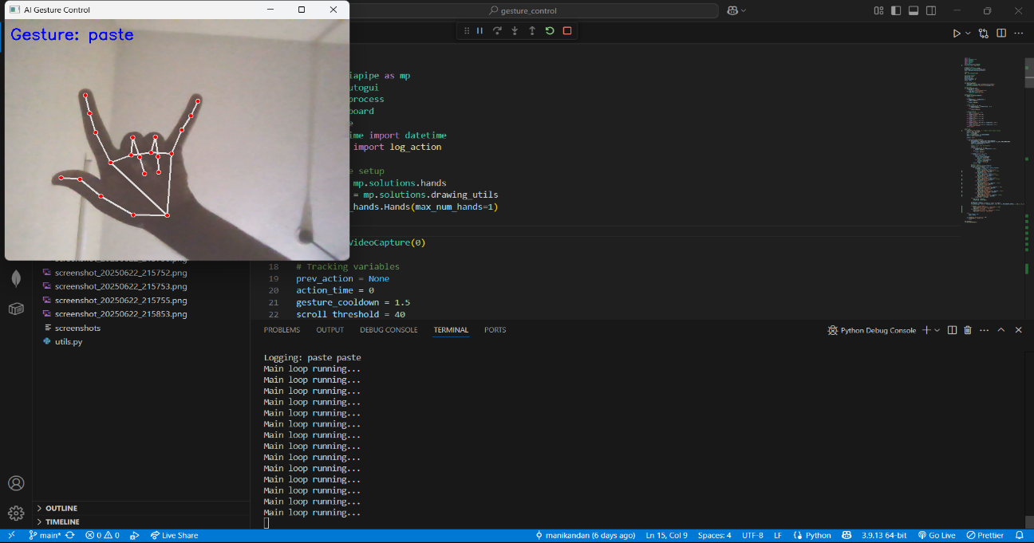

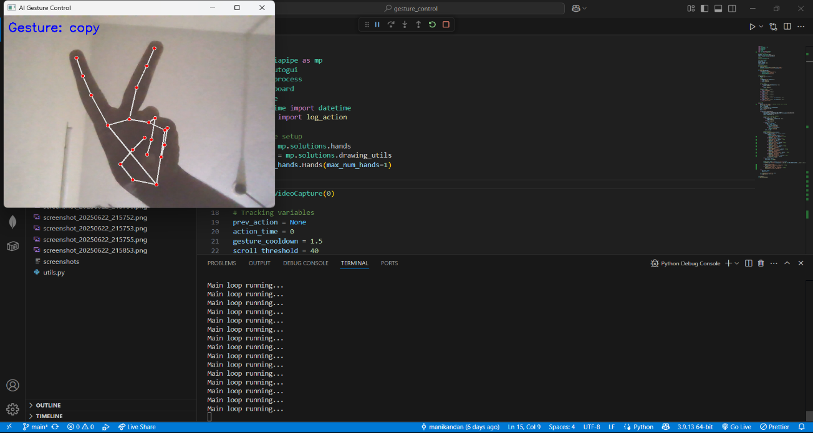



**6.STUDENT LEARNING OUTCOMES**

**Application of Engineering Knowledge**

* Applied concepts from computer vision, artificial intelligence, and automation to solve a real-world problem.
* Integrated programming, hardware interaction (webcam), and AI models effectively.

**Technical Skill Development**

* Gained hands-on experience in using libraries such as **MediaPipe**, **OpenCV**, and **PyAutoGUI**.
* Improved proficiency in **Python programming** and real-time image processing techniques.

**Problem Analysis & Logical Thinking**

* Identified technical challenges in gesture recognition and implemented logical solutions.
* Enhanced debugging, testing, and optimization skills to ensure system reliability.

**Innovation and Creativity**

* Designed a touchless control system that replaces traditional input devices using simple hand gestures.
* Showcased creative thinking in mapping gestures to useful computer commands.

**Teamwork and Communication**

* Collaborated effectively with team members during planning, development, and testing.
* Presented and documented the project clearly for peer and faculty understanding.

**Use of Modern Tools**

* Utilized open-source tools and modern frameworks for AI and automation.
* Learned project version control using **Git and GitHub**, preparing for industry-standard software workflows.

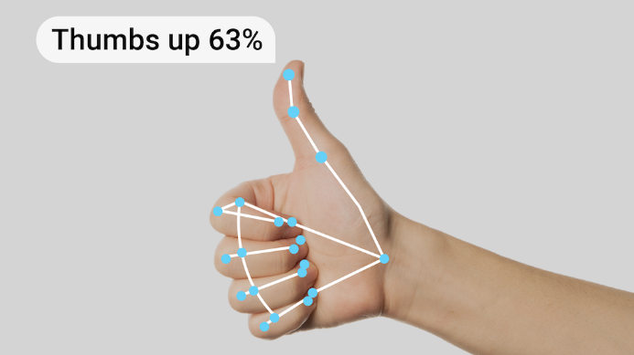**Lifelong Learning and Adaptability**

* Adapted to new technologies, explored open-source AI tools, and expanded knowledge beyond the curriculum.
* Demonstrated curiosity and initiative in learning new programming techniques and tools.

**7.FUTURE SCOPE**

**Short-Term Enhancements:**

* Custom gesture training module
* Multi-language application support
* Background process prioritization

The **AI-Based Hand Gesture Control System** presents significant potential for further development and real-world applications. As technology continues to evolve, this system can be expanded and refined in various ways to increase its accuracy, usability, and practical adoption.

**🔹 1. Integration with Smart Devices**

* Extend gesture control to smart TVs, home appliances, and IoT-enabled devices.
* Create a smart home control system operated entirely by hand gestures for enhanced comfort and accessibility.

**🔹 2. Enhanced Gesture Recognition with Deep Learning**

* Implement advanced deep learning models to improve gesture accuracy, even in low-light or noisy backgrounds.
* Add support for custom gestures using training data specific to different users.

**🔹 3. Support for AR/VR Applications**

* Integrate gesture controls in augmented reality and virtual reality platforms for immersive experiences in gaming, simulation, and education.

**🔹 4. Cross-Platform Compatibility**

* Develop the system as a standalone desktop or mobile app compatible with Windows, Linux, macOS, and Android.
* Enable usage on smartphones using the front camera for gesture-based navigation and controls.

**🔹 5. Accessibility for Differently-Abled Users**

* Design gesture systems specifically to help physically challenged individuals interact with digital devices without needing keyboards or mice.

**🔹 6. Gesture + Voice Hybrid Control**

* Combine speech recognition with gestures for more natural and intuitive human-computer interaction.

**🔹 7. Custom GUI and Feedback**

* Add a visual GUI that shows recognized gestures in real-time and gives voice or visual feedback for each action.

**8.SOFTWARE DEVELOPMENT**

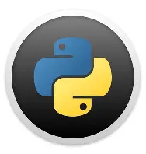**Python**

A high-level programming language used to develop the entire system. Python supports powerful libraries for computer vision, machine learning, and automation, making it ideal for gesture-based control systems.

**OpenCV (Open Source Computer Vision Library)**

 Used for capturing and processing images and videos from the webcam. It helps in:

* Real-time video streaming
* Frame-by-frame processing
* Drawing hand landmarks and gesture visuals

**PyAutoGUI**

A Python library used to simulate mouse and keyboard actions.  
Functions include:

* Move cursor to specific screen coordinates
* Click, type, scroll
* Perform actions like cut, copy, paste, screenshot, etc.

**MediaPipe**

 An open-source AI framework developed by Google for real-time hand, face, and pose tracking.  
In this project, it:

* Detects 21 hand landmarks
* Tracks finger movements and positions
* Identifies gesture patterns like open fingers or closed fists

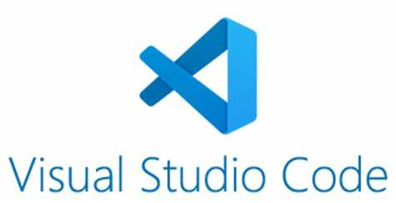**Visual Studio Code**

A lightweight, cross-platform code editor used for writing, testing, and debugging the Python code. It offers:

* Extension support (Python, Git, Linting)
* Terminal integration
* Syntax highlighting and auto-completion

**Webcam (Built-in or USB)**

Used as the primary input device to capture hand gestures in real-time.  
It enables:

* Continuous video feed for gesture detection
* Frame input for OpenCV and MediaPipe to process
* Accurate tracking of finger positions

**9.Application / Industry Relevance**

****This system is highly relevant in industries seeking hygienic, touchless interfaces:

* Healthcare – For sterile, contact-free computer interaction.
* Consumer Electronics – In smart TVs and gesture-based user interfaces.
* 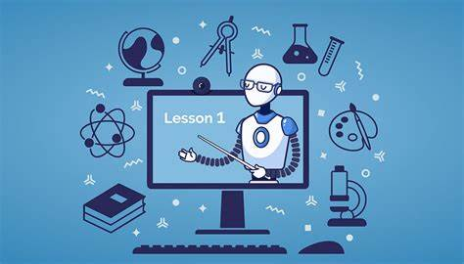Assistive Technology – Helping individuals with disabilities control systems.
* Education – For gesture-based classroom control or presentations.
* Industrial Automation – Hands-free control of systems in factories.

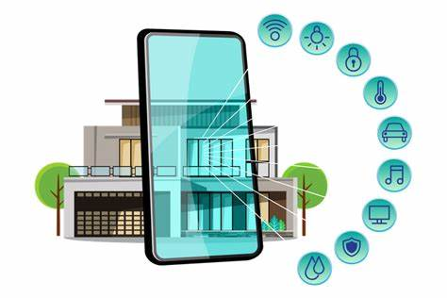

* Smart Homes – Control lights, fans, or devices using hand signs**.**

**10.Testing, Final Assembly, and Troubleshooting**

**Testing**

Real-time gesture detection was tested across varied lighting conditions and backgrounds**.**

**Final Assembly**

## The final system setup included the following:

## A Python-based program with gesture recognition logic.

## A standard webcam (built-in or USB) for capturing hand movements.

## Required Python libraries installed via pip (OpenCV, MediaPipe, PyAutoGUI).

## The system packaged into a folder with:

## main.py (core script)

## requirements.txt (library dependencies)

## README.md (usage instructions)

## **Troubleshooting:**

## During development and testing, several issues were encountered and resolved:

| **Issue** | **Cause** | **Solution** |
| --- | --- | --- |
| Gesture not detected | Poor lighting or hand not in frame | Improved camera angle and added brightness handling |
| Wrong action triggered | Gesture overlaps or fast movement | Increased gesture distinction and added short delays |
| PyAutoGUI not working | Screen resolution issues | Ensured consistent screen coordinate mapping |
| Screenshot not saving | File permission errors | Added default directory path and filename timestamp |
| Lag or delay in response | High CPU usage | Optimized frame processing and added delays to reduce load |

**KEYS TO SYMBOLS:**

* ✊ = Closed fist (all fingers bent)
* 👆 = Index finger extended (pointing)
* ✌️ = Victory/peace sign (index + middle extended)
* 🤞 = Crossed fingers (index + middle extended and crossed)
* 🤟 = (thumb + index + pinky extended)
* 👉 = Pointing right
* 👈 = Pointing left
* 🖐️ = Open palm (all fingers extended)
* ⬆️ = Upward movement
* ⬇️ = Downward movement

**11.Conclusion and Recommendations**

The AI-Based Hand Gesture Control System provides a functional and practical method for human-computer interaction. It demonstrates the integration of AI, automation, and usability in a real-world application. Future work should include enhancing gesture training using machine learning models and expanding to cross-platform compatibility and IoT systems.